**Running Scala on Kubernetes**

**docker pull mesosphere/spark**

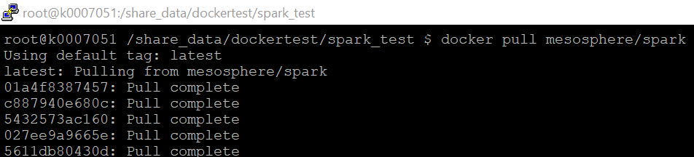

Digest: sha256:3de6c2ae5eb60ca056048a1bbf098476b1117635eaaa612940db34e47ac22371

Status: Downloaded newer image for mesosphere/spark:latest

**docker images or docker images -a**

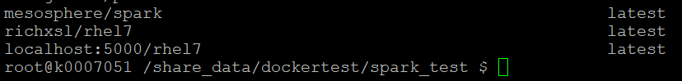

root@k0007051 /share_data/dockertest/spark_test $ docker images | grep mesosphere/spark

mesosphere/spark latest 5c25c7985707 11 months ago 1.42GB

docker tag mesosphere/spark k0007051:5000/spark_test



**docker run --name=testspark -d -it --net=host -v /share_data:/share_data k0007051:5000/spark_test**docker run -v /share_data:/share_data k0007051:5000/spark_test

Docker ID

75ae2dd8ac4c5bba87b1ae8cbef87b16d73bd946638fa9407c7c1f994408129b

docker exec -it 75ae2dd8ac4c5bba87b1ae8cbef87b16d73bd946638fa9407c7c1f994408129b bash

./spark-submit --class Merge --master local[*] /share_data/sample1_2.11-2.3.2.jar

//docker push k0007051:5000/spark_test

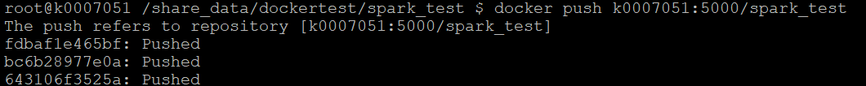



latest: digest: sha256:8044457acfa30dd487e300dee11144f7dcf47cc4ac05f58d84fc8333b218a239 size: 5746

You have new mail in /var/spool/mail/root

Create the YAML file

root@k0007051 /share_data/dockertest/spark_test $ cat spark_test.yaml

spark_test.yaml

apiVersion: v1

kind: Pod

metadata:

name: spark-test

spec:

containers:

- image: k0007051:5000/spark_test

name: spark-test

volumeMounts:

- name: share-data

mountPath: /share_data

volumes:

- name: share-data

hostPath:

path: /share_data

type: Directory

restartPolicy: Never

kubectl create -f spark_test.yaml



kubectl get pods --all-namespaces |grep spark

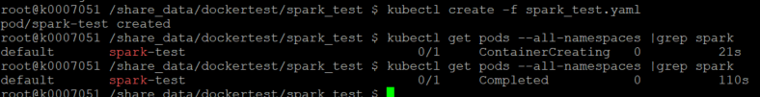

kubectl logs spark-test | head

I’m not getting any result from this. It’s supposed to be showing the newResult here.



kubectl delete pod spark-test